
a
Company
Logotype

Cone Beam Computed Tomography- Report



Porur Dental X-rays & CBCT

Patient Name : Mrs. Sasikumari | Date of Report : 23.04.2024
Age/ Gender : 70 years/ Female | Region of Interest : CBCT Maxilla
Referring doctor: Dr. V. Nethaji | Indication : Implant assessment
Clinical Notes: Nil
PATIENT INFORMATION

CBCT- Maxilla provided
CBCT – IMAGE DETAILS

RADIOGRAPHIC INTERPRETATION

- Hyperdense crown structure present in relation to 21, 22, 23.
- Fractured crown: 24, 25,26.
- Root stump: 27
- The maxillary alveolar ridge is present with normal trabecular pattern.

IMPLANT ASSESSMENT

 | 21 region | 22 region | 23 region | 24 region
Sub-Crestal | 5.64 | 4.26 | 4.48 | 7.46
Mid- Crestal | 5.14 | 3.99 | 4.23 | 5.64
Distance between the alveolar ridge and Floor of the Nasal cavity (in mm) | 14.12 | 18.28 | 15.31 | 18.39

 | 25 region | 26 region | 27 region
Sub-Crestal (in mm) | 7.03 | 10.16 | 10.59
Mid- Crestal (in mm) | 6.09 | - | 11.03
Distance between the alveolar ridge and floor of the maxillary sinus (in mm) | 16.81 | 5.24 | 8.28

RADIOGRAPHIC IMPRESSION

- Partially edentulous maxillary arch.
- Fractured crown: 24, 25,26.
- Root stump: 27

Kindly correlate with clinical findings


IMAGES FOR REFERENCE

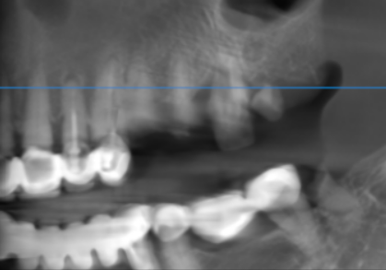

3-DIMENSIONAL VIEW

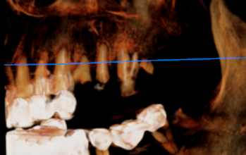

CROSS SECTIONAL VIEW

21 region | 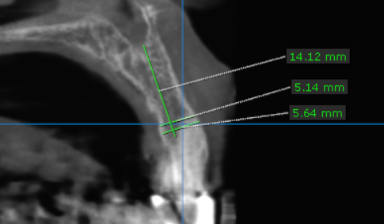
22 region | 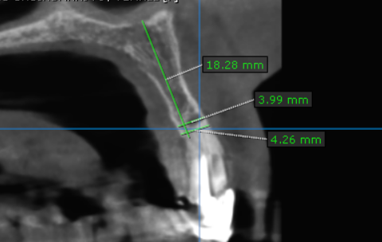
23 region | 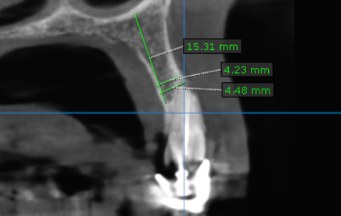
24 region | 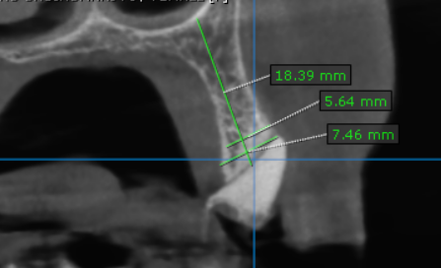
25 region | 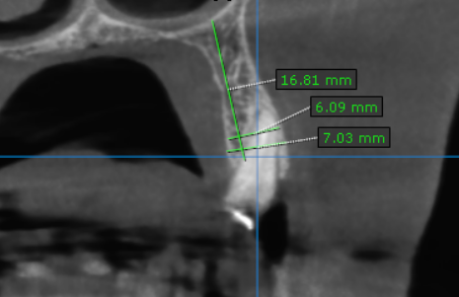
26 region | 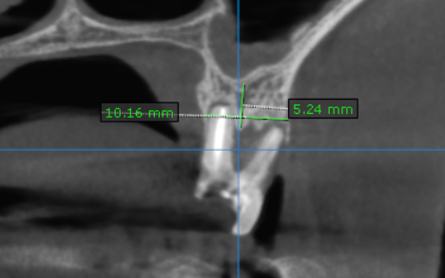
27 region | 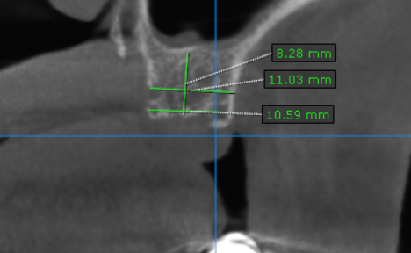

**** End of report ****

